A
Major project
On

STABILITY MONITORING SYSTEM FOR EARLY LANDSLIDE DETECTION AND RISK MITIGATION
Submitted in partial fulfillment of the Requirements for the award of
Degree of
BACHELOR OF TECHNOLOGY
ELECTRONICS & COMMUNICATION ENGINEERING
BY
T.ANUSHA - 22681A0455
MD IMRAN - 22681A0437
K.RAGHAVENDRA - 22681A0430

Under the esteemed guidance of
Mr. K. CHIRANJEEVI
(Assistant professor)



Signature of Guide Signature of Co-ordinator
(Mr. K.Chiranjeevi) (Mr. B. Sandeep Kumar)

Signature of HOD
(Mr. Allanki Sanyasi Rao)

ABSTRACT
Landslides pose a significant threat to human life, infrastructure, and the environment, particularly in hilly and mountainous regions. Early detection and timely warnings are crucial for minimizing damage and ensuring safety. This project proposes a cost-effective, real-time stability monitoring system for early landslide detection and risk mitigation using an IoT-based approach. The system utilizes a NodeMCU (ESP8266) microcontroller as the central processing and communication unit, interfaced with a soil moisture sensor, DHT11 sensor (for temperature and humidity), and a vibration sensor (such as SW-420).
These sensors continuously monitor key environmental parameters that influence slope stability, including soil saturation levels, ambient temperature and humidity, and ground vibrations. The collected data is transmitted wirelessly to a cloud platform or local server, where it can be monitored in real time. Threshold values are predefined for each sensor to identify critical conditions indicative of a potential landslide. Upon detecting abnormal readings—such as high soil moisture levels, rapid temperature changes, or sudden vibrations—the system triggers an alert mechanism (e.g., buzzer, SMS, or cloud notification), enabling timely evacuation or preventive actions.
The proposed system is designed to be low-cost, scalable, and suitable for deployment in remote or vulnerable areas. By integrating environmental sensing with IoT capabilities, this project demonstrates an effective and proactive approach to landslide risk management and disaster preparedness.
This wireless landslide detection system provides a real-time, automated, and reliable solution for early warning and disaster prevention, helping authorities and communities take timely preventive actions to minimize damage and save lives.

PROBLEM STATEMENT
- Landslides are one of the most destructive natural disasters, causing significant loss of life, property damage, and environmental degradation worldwide. In mountainous and hilly regions, particularly those with unstable geological formations or heavy rainfall, the risk of landslides is amplified. Traditional methods of landslide monitoring—such as manual surveys and visual inspections—are time-consuming, costly, and often ineffective in providing early Manual warnings.
There is an urgent need for a robust, data-driven, and scalable landslide detection and mitigation system that can:
- Continuously monitor environmental and geotechnical parameters using IoT sensors, remote sensing, or satellite imagery.
- Predict Provide real-time alerts to local authorities and communities at risk.
- potential landslide events using machine learning or physics-based models.
Support decision-making for land-use planning, infrastructure development, and disaster preparedness.
Solution Approach:
- Sensor-Based Monitoring:
- Install IoT sensors to track rainfall, soil moisture, and slope movement in real time.
- Use wireless networks to transmit data continuously for analysis.
  - Remote Sensing & Satellite Data:
- Employ satellite imagery (e.g., InSAR, LiDAR) and drones for surface deformation and terrain analysis.

- Machine Learning & AI Models:
- Train predictive models using historical landslide, rainfall, and terrain data to forecast future events.
- GIS-Based Hazard Mapping:
- Combine multiple factors (slope, soil, rainfall, vegetation) in GIS to create landslide susceptibility maps.
- Early Warning Systems:
- Set up automated alerts (SMS, sirens, dashboards) when risk thresholds are exceeded.
- Engineering Mitigation Measures:
- Construct retaining walls, proper drainage systems, and reforestation to stabilize slopes.
  - Policy & Community Measures:
- Enforce land-use zoning, raise public awareness, and develop evacuation and emergency plans.
- Integrated Decision Support System:
- Combine sensor data, predictive analytics, and GIS tools for real-time monitoring and disaster management.

BLOCK DIAGRAM

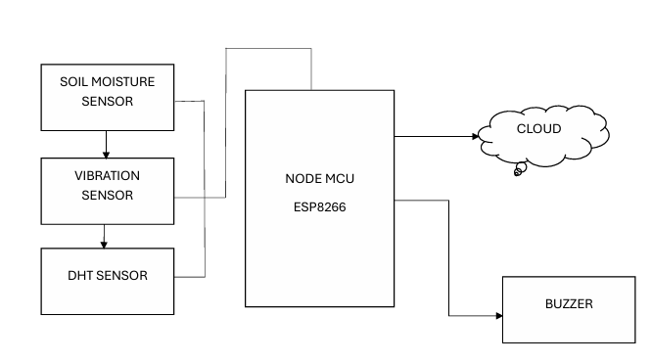
LED SENSOR

INTRODUCTION
Landslides are one of the most destructive natural hazards, characterized by the downward movement of rock, soil, or debris under the influence of gravity. They can occur suddenly and cause severe damage to human lives, infrastructure, and the environment. Landslides are common in mountainous and hilly regions where slopes are steep and unstable. Natural factors such as heavy rainfall, earthquakes, volcanic activity, and soil erosion often trigger landslides. However, human activities like deforestation, mining, road construction, and unplanned urbanization have also significantly increased their occurrence and intensity. As the effects of climate change intensify, leading to more extreme weather events, the risk of landslides is expected to rise globally.
Landslide detection is a crucial step in understanding slope stability and preventing disasters before they occur. Detecting early signs of slope movement can help authorities issue timely warnings and implement preventive measures. Traditional methods of detection relied on field surveys and visual inspections, which were often time-consuming and limited in scope. Today, modern technologies such as remote sensing, Geographic Information Systems (GIS), and ground-based monitoring have revolutionized the way landslides are detected and studied. These methods enable continuous observation and provide detailed data on surface deformation, ground movement, and soil moisture levels, which are essential for early warning systems.
Advanced technologies like satellite imagery, LiDAR (Light Detection and Ranging), and InSAR (Interferometric Synthetic Aperture Radar) have become vital tools in landslide detection and mapping. These technologies can capture high-resolution data over large areas, allowing for accurate identification of potential landslide zones. Additionally, sensor-based monitoring systems using Internet of Things (IoT) technology have made it possible to track slope movements in real-time. Such innovations allow scientists and disaster management agencies to analyze data continuously, predict potential failures, and take immediate action to reduce risks.
Risk mitigation focuses on minimizing the impacts of landslides through preventive and corrective measures. Structural approaches include engineering solutions such as slope reinforcement, retaining walls, drainage systems, and reforestation to stabilize slopes. Non-structural measures involve proper land-use planning, hazard mapping, community awareness programs, and the establishment of early warning systems. Integrating both detection and mitigation strategies helps build a comprehensive landslide risk management framework. By combining scientific research, modern technology, and community participation, societies can enhance resilience, protect lives and property, and ensure sustainable development in landslide-prone regions.

SOFTWARE

ARDUINO IDE
Arduino is an open-source electronics platform that combines easy-to-use hardware and software to facilitate the creation of interactive electronic projects. It features a range of microcontroller boards, like the Arduino Uno, which are programmed through the Arduino IDE using a simplified version of C/C++. This user friendly approach, along with extensive libraries and community support, makes Arduino ideal for prototyping, educational purposes, and hobbyist projects, enabling users to interface with sensors, actuators, and other components to build various applications.
- Cross-platform: Works on multiple operating systems (Windows, macOS, Linux).
- Free and Open-source: Free to use, modify, and distribute.
- User-friendly: Easy to use, even for beginners.
- Syntax Highlighting: Color-codes code for easier reading. • Auto-completion: Suggests code completions as you type.
- Code Folding: Hides and shows sections of code.
The key features are:
- Arduino board are able to read analog or digital input signals from different sensors and turn it into an output such as activating a motor, turning LED on/off, connect to the cloud and many other actions.
- Can control your board functions by sending a set of instructions to the microcontroller on the board via Arduino IDE (referred to as uploading software).
- Unlike most previous programmable circuit board, Arduino does not need an extra piece of hardware (called a programmable) in order to load a new code onto the board. You can simply use a USB cable.
After learning about the main parts of the Arduino UNO board. We are ready to learn how to set up the Arduino IDE. Once we learn the, we will ready to upload our program on the Arduino board.
ARDUINO DATA TYPES:
Data types in C refers to an extensive system used for declaring variable or functions of different types. The type of a variable determines how much ace it occupies in the storage and how the bit pattern stored is interpreted.
The following table provides all the data types that you will use during Arduino programming.
Void:
The void keyword is used only in function declaration. It indicates that the functions is expected to return no information to the functions from which it was called.
Example:
Void Loop () {
// rest of t code
}
Boolean: A Boolean holds one of two values, true or false. Each Boolean variable occupies one byte of memory.
Chart: A data type that takes up one byte of memory that stores a character value. Character literals are written in single quotes like this: ‘A’ and for multiple characters, strings use double quotes: “ABC”.
However, characters are stored as numbers. You can see the specific encoding in the ASCII chart. This means that it is possible to do arithmetic operations on characters, in which the ASCII value of the character is used. For example, ‘A’ +1 has the value 66, since the ASCII value of the capital of the capital letter a is 65.
Unsigned char is an unsigned data type that occupies one byte of memory. The unsigned char data type encodes numbers from 0 to 255. Byte: A byte stores an 8-bit unsigned number, from 0 to 255.

Int: Integers are the primary data-type for numbers storage. int stores a 16-bit (2-byte) value. This yields a range of -32,768 to 32,767 (minimum value of -2^15 and a maximum value of (2^15)-).
The Int size varies from board to board. On the Arduino due, for example, an int stores a 32-bit (4-byte) value.
Unsigned int: Unsigned int (unsigned integers) are the same as int in the way that they store a 2byte value. Instead of storing negative numbers, however, they only store positive values, yielding a useful range of 0 to 65,535 (2^16). The due stores a 4byte (32-bit) value, ranging from 0 to 4,294.967.295 (2^32-).
Word: On the Uno and other A TMEGA based boards, a word stores a 16-bit unsigned number. On the due and zero, it stores a 32-bit unsigned number.
Long: Long variables are extended size variable for number storage, and store 32 bit (4 bytes), from 2,147,483,648 to 2,147,483,647.
Unsigned long: Unsigned long variables are extended size variables for number storage and store 32 bits (4 bytes). Unlike standard longs, unsigned longs will not store negative numbers, making their range from 0 to 4,294,967,295 (2^32 - 1).
Short: A short is a 16-bit data-type. On all Arduinos (AT Mega and ARM based), a short stores a 16-bit (2-byte) value. This yields a range of -32,768 to 32,767 (minimum value of -2^15 and a maximum value of (2^15) - 1).
Float: Data type for floating-point number is a number that has a decimal point. Floating-point numbers are often used to approximate the analog and continuous values because they have greater resolution than integers. Floating-point numbers can be as large as 3.4028235E+38 and as low as 3.4028235E+38. They are stored as 32 bits (4 bytes) of information.
Double: On the Uno and other ATMEGA based boards, Double precision floatingpoint number occupies four bytes. That is, the double implementation is exactly the same as the float, with no gain in precision. On the Arduino Due, doubles have 8-byte (64 bit) precision.
In this section, we will learn in easy steps, how to set up the Arduino IDE on our computer and prepare the board to receive the program via USB cable.
Step 1: First you must have your Arduino board (you can choose your favorite board) and a USB cable. In case you use Arduino UNO, Arduino duemilanove, Nano, Arduino Mega2560, or Decimal, you will need a standard USB cable (A plug to B plug), the kind you would connect to a USB printer as shown in the following image.
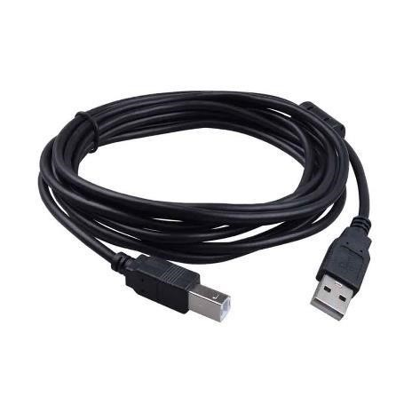
Fig: USB cable

Step 2: Download Arduino IDE Software.
You can get different versions of Arduino IDE from the Download page on the Arduino Official website. You must select your software, which is compatible with your operating system (Windows, IOS, or Linux). After your file download is complete, unzip the file.
Step 3: Power up your board.
The Arduino Uno, Mega, Duemilanove and Arduino Nano automatically draw power from either, the USB connection to the computer or an external power supply. If you are using an Arduino Decimal, you have to make sure that the board is configured to draw power from the USB connection. The power source is selected with a jumper, a small piece of plastic that fits onto two of the three pins between the USB and power jacks. Check that it is on the two pins closest to the USB port.
Connect the Arduino board to your computer using the USB cable.
Step 4: Launch Arduino IDE.
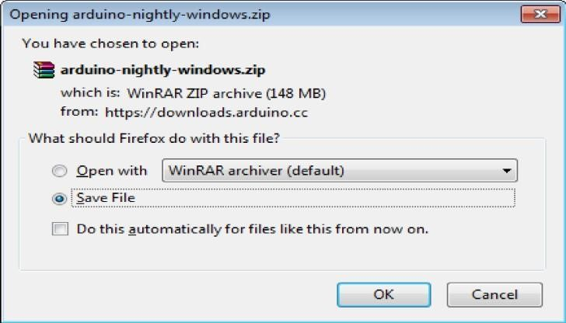

Fig : Launch Arduino IDE
After your Arduino IDE software is downloaded, you need to unzip the folder. Inside the folder, you can find the application icon with an infinity label (application.exe). Double click the icon to start the IDE.
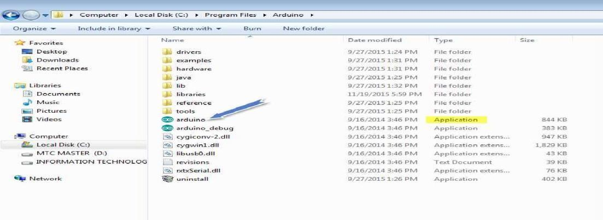
Step 5: Open your first project. Once the software starts, you have two options:
- Create a new project.
- Open an existing project example.
To create a new project, select File --> New. To open
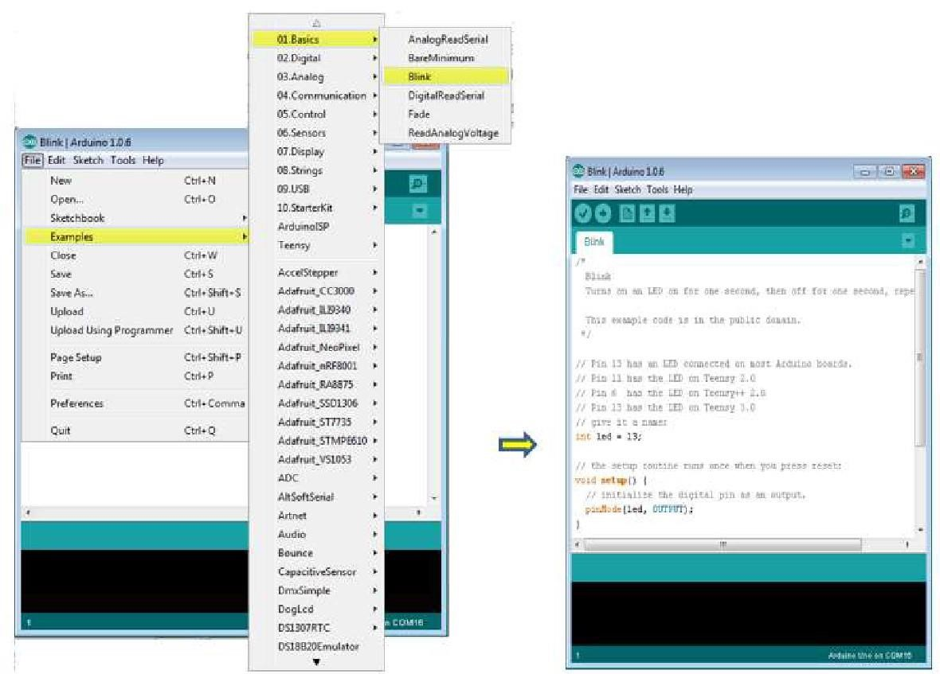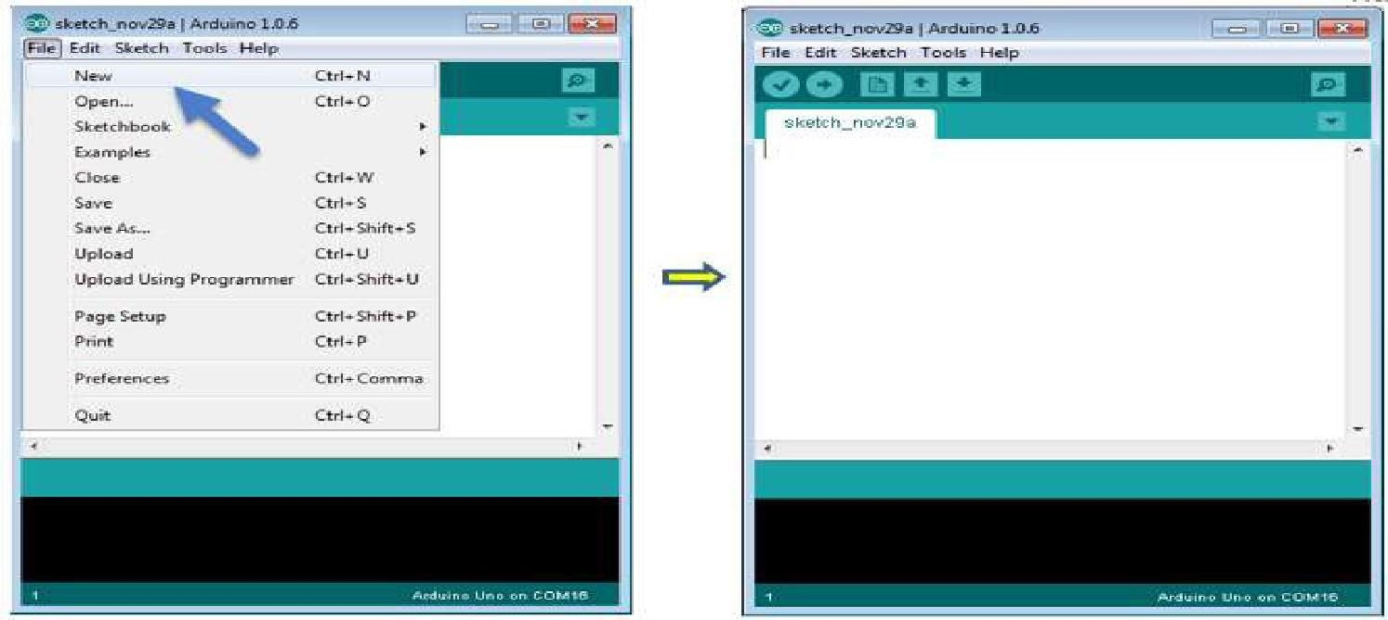
To open an existing project example, select File -> Example -> Basics -> Blink.
Here, we are selecting just one of the examples with the name Blink. It turns the LED on and off with sometime delay. You can select any other example from the list.
Step 6: Select your Arduino board: To avoid any error while uploading your program to the board, you must select the correct Arduino board name.
which matches with the board connected to your computer.
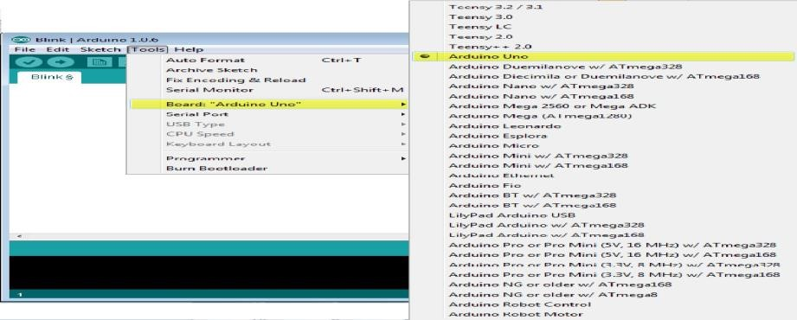
Here, we have selected Arduino Uno board according to our tutorial, but you must select the name matching the board that you are
Step 7: Select your serial port. Select the serial device of the Arduino board. Go to Tools ->Serial Port menu. This is likely to be COM3 or higher (COM1 and COM2 are usually reserved for hardware serial ports). To find out, you can disconnect your Arduino board and re-open the menu, the entry that disappears should be of the Arduino board. Reconnect the board and select that serial port.
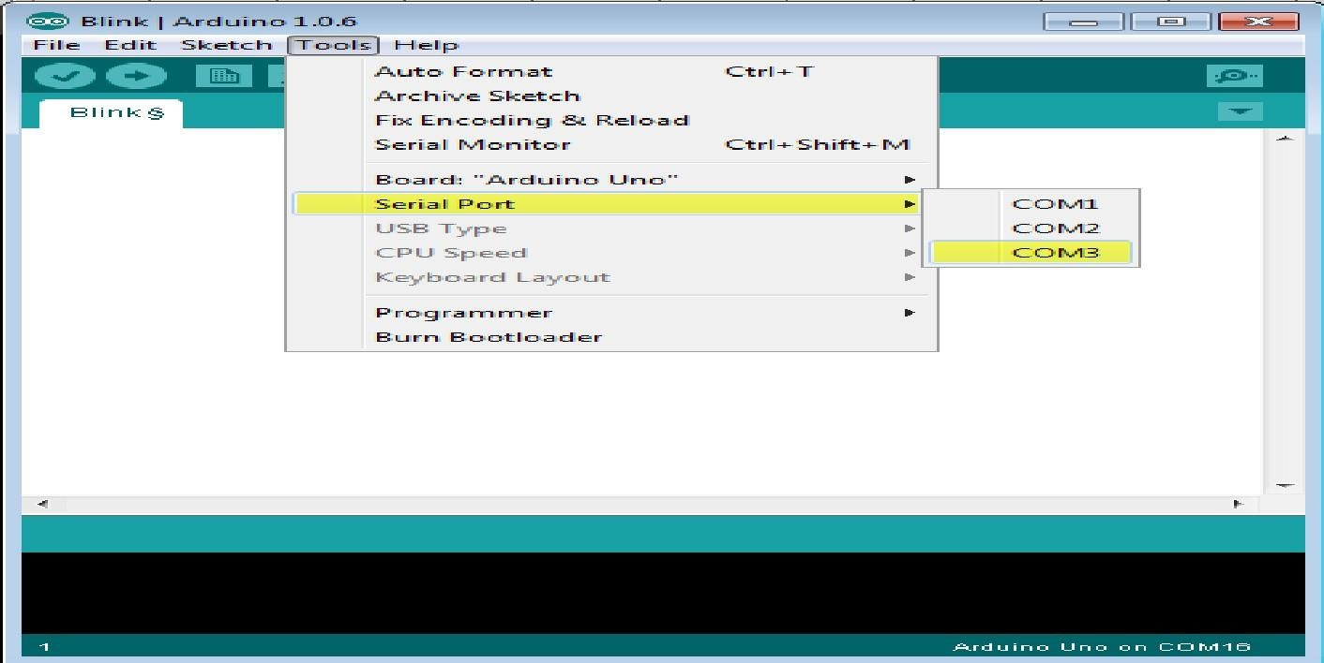

Step 8: Upload the program to your board. Before explaining how we can upload our program to the board, we must demonstrate the function of each symbol appearing in the Arduino IDE toolbar.
- Used to check if there is any compilation error.
- Used to upload a program to the Arduino board.
- Shortcut used to create a new sketch.

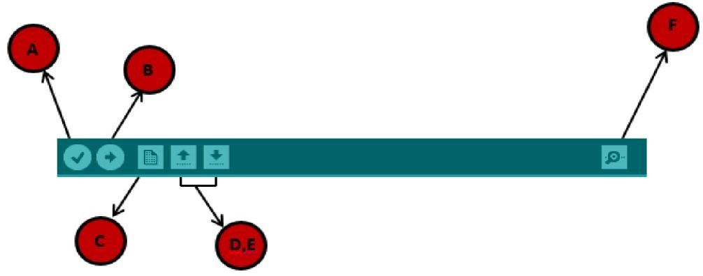
- Used to check if there is any compilation error.
- Used to upload a program to the Arduino board.
- Shortcut used to create a new sketch.
- Used to directly open one of the example sketch.
- Used to save your sketch.
- Serial monitor used to receive serial data from the board and send the serial data to board.
Now, simply click the "Upload" button in the environment. Wait a few seconds; you will see the RX and TX LEDs on the board, flashing. If the upload is successful, the message "Done uploading" will appear in the status bar.
Note: If you have an Arduino Mini, NG, or other board, you need to press the reset button physically on the board, immediately before clicking the upload button on the
Arduino Software.
Arduino programming structure
In this chapter, we will study in depth, the Arduino program structure and we will learn more new terminologies used in the Arduino world. The Arduino software is opensource
Sketch: The first new terminology is the Arduino program called “sketch”.
Structure: Arduino programs can be divided in three main parts: Structure, Values (variables and constants), and Functions. In this tutorial, we will learn about the Arduino software program, step by step, and how we can write the program without any syntax or compilation error.
Let us start with the Structure. Software structure consist of two main functions:
- Setup( ) function
- Loop( ) function Void setup ( )
{ }

LITERATURE SURVEY

Ramesh et al. (2017) designed a wireless sensor network (WSN) for monitoring slope movements using tilt sensors, rain gauges, and soil moisture sensors. The system continuously collected ground deformation data and transmitted it to a remote server. Their prototype successfully demonstrated real-time monitoring capability and timely alerts before slope failure, proving the potential of WSNs in early warning systems for landslides.

Gupta and Mehta (2019) developed an IoT-enabled landslide warning system that integrated geotechnical sensors (tilt, vibration, and moisture sensors) with a cloud platform. Data from the field was transmitted via GSM modules for real-time analysis. Their research showed that IoT technology could significantly improve response time and reduce data loss during adverse weather conditions, allowing authorities to take preventive actions faster.

Chen et al. (2020) implemented a Micro-Electro-Mechanical System (MEMS)-based inclinometer array for detecting minute changes in slope angle and soil displacement. The MEMS sensors provided high-resolution data, enabling detection of small precursors to large-scale failures. The study highlighted the advantage of MEMS in providing reliable and low-cost monitoring solutions suitable for continuous field deployment.

Singh and Rao (2021) analyzed the use of InSAR (Interferometric Synthetic Aperture Radar) and optical satellite imagery for regional-scale landslide detection. Their study combined remote sensing data with ground-based IoT sensors for validation. The hybrid approach improved spatial coverage and early identification of active landslide zones, demonstrating the value of multi-sensor fusion for comprehensive risk assessment.

Kumar et al. (2023) proposed a machine learning–based predictive model that utilized environmental and sensor data (rainfall, soil moisture, vibration) to forecast landslide occurrences. Using real-time datasets, their model achieved high accuracy in predicting slope failures and issuing timely alerts. The integration of AI with sensor networks showed great promise for proactive landslide risk mitigation and decision support.

EXISTING SYSTEM
Currently, landslide detection and monitoring in most hilly and mountainous regions are conducted manually or semi-automatically. Field engineers and geologists periodically inspect vulnerable slopes to record visible cracks, soil displacement, and surface water accumulation. In some areas, rainfall intensity and soil moisture are observed through standalone sensors; however, these readings are not integrated into a centralized monitoring or alerting platform. As a result, the system often fails to provide real-time, continuous monitoring or early warnings before a landslide occurs.
Conventional methods depend heavily on periodic field surveys, satellite images, or visual inspections, which can identify landslides only after significant ground movement has already taken place. Any changes in slope stability are usually detected after the onset of failure, leaving little time for preventive measures or evacuation.
No Real-Time Monitoring:Continuous observation of key parameters like soil movement, ground vibration, and moisture content is absent, delaying early detection of slope instability.
Manual Data Collection:Current systems depend on field inspections and manual measurement, which are time-consuming, labor-intensive, and prone to human error.
Reactive Approach:Landslides are often identified only after visible damage occurs, providing little or no time for preventive action.
Lack of Integration:Most systems are isolated and do not combine data from multiple sensors (rainfall, vibration, soil moisture), reducing accuracy in risk assessment.
Poor Data Management:Collected data is not centralized or stored in digital form, preventing long-term trend analysis and predictive modeling.

PROPOSED SYSTEM
The proposed landslide detection and risk mitigation system is designed to monitor environmental and ground conditions that often cause landslides by using affordable and easily accessible components. At the heart of the system is the Arduino Uno microcontroller, which collects data from several sensors to detect signs of a potential landslide.
The system uses the following sensors:
- DHT Sensor: Measures temperature and humidity to track weather conditions that affect soil moisture.
- Vibration Sensor: Detects any unusual ground vibrations or tremors that may indicate soil movement.
- Tilt Sensor: Monitors changes in slope or ground tilt, providing early warning if the land begins to shift.
- Soil Moisture Sensor: Measures the moisture level in the soil, since heavy rainfall or waterlogging can destabilize slopes.
All sensor data is sent to the Arduino Uno, which processes the information continuously. If any sensor readings go beyond safe thresholds—such as excessive soil moisture, high vibration levels, or significant tilt changes—the system activates visual alerts using LEDs. For example, a red LED turns on to warn residents of possible landslide risk, while a green LED indicates normal, safe conditions.
This system can also be enhanced by adding wireless communication modules to send alerts remotely to authorities or nearby residents via SMS or mobile apps. This real-time monitoring and alert system helps communities take timely preventive actions, such as evacuation or reinforcing slopes, to reduce the risk of damage and loss of life due to landslides.
Overall, the proposed system offers a simple, cost-effective, and reliable way to detect landslide hazards early and improve safety in vulnerable areas.

